|  |  |
| --- | --- |
| Name Of The Student | SAHIL SENGRA |
| Internship Project Topic | WEBPAGE UI DESIGN |
| Name of the Organization | TCS-ION |
| Name of the Industry Mentor | Atul Devrukhka, Anushree_deshpande ( Administrator ) |
| Name of the Institute | PREPINSTA |

|  |  |  |
| --- | --- | --- |
| Date | Day # | Hours Spent |
| 27-12-2022 | 6 | 4.5HR |
| Activities done during the day:   1. Went through the links given in the project reference material, and tried to connect it with the project objective. 2. Making of Home Page & Banner 3. I attached all my project till now. 4. This word file contains logos, framework design, homepage UI Design & Some SubPages UI design.   Please Evaluate my project.. if any error is come please tells me.  My assignment is given below. | | |

Home Page & Subpages

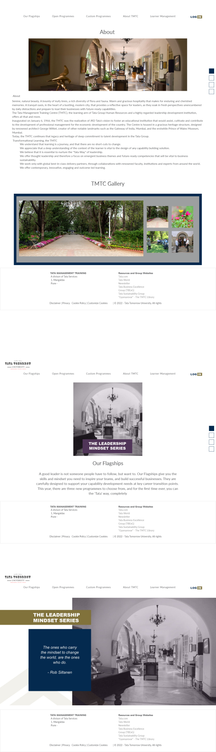



CLICK THIS ICON : THIS IS THE LOGO  
  
 

HERE THE PNG FILE OF MY FRAME WORK

